International Spring Semester
2024

Social Science and politics French Language

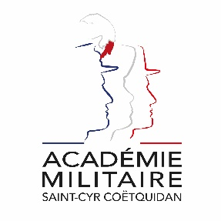
Military Academy of Saint-Cyr Coëtquidan

ERASMUS ID CODE | FGUER01
Contact | Lieutenant (OF-1) Charlie OFFERLIN  Mail : cyr.international@st-cyr.terre-net.defense.gouv.fr  Phone : +33 2 97 70 73 75
Dates | Starts : 24th January 2024  Ends : 14th June 2024  Arrival date : 23th January 2024 (Kindly respect this date)  Dates might evolve
Student Requirements | English language B1 or 785 TOEIC
Application file | - Application form  - Medical Certificate  - Reduced Medical Booklet  - ID or Passport scan  - 1 ID photograph  Applications must be sent no later than 18th December 2023.
Meals & Accommodation | According to EMILYO-LoD 5 (framework), accommodation, meals, and other expenses in relation to the education are free of charge for members of European Union Basic Officer Education Institutions (http://www.emilyo.eu/node/982).

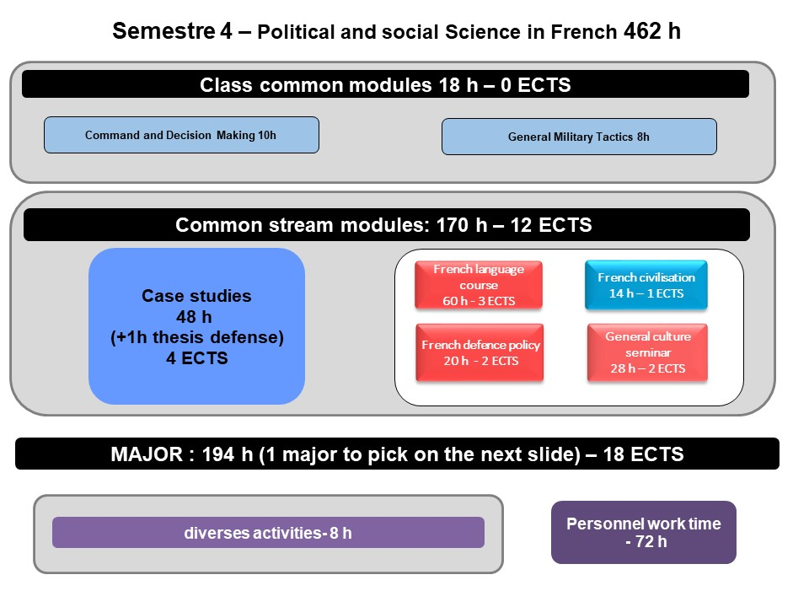
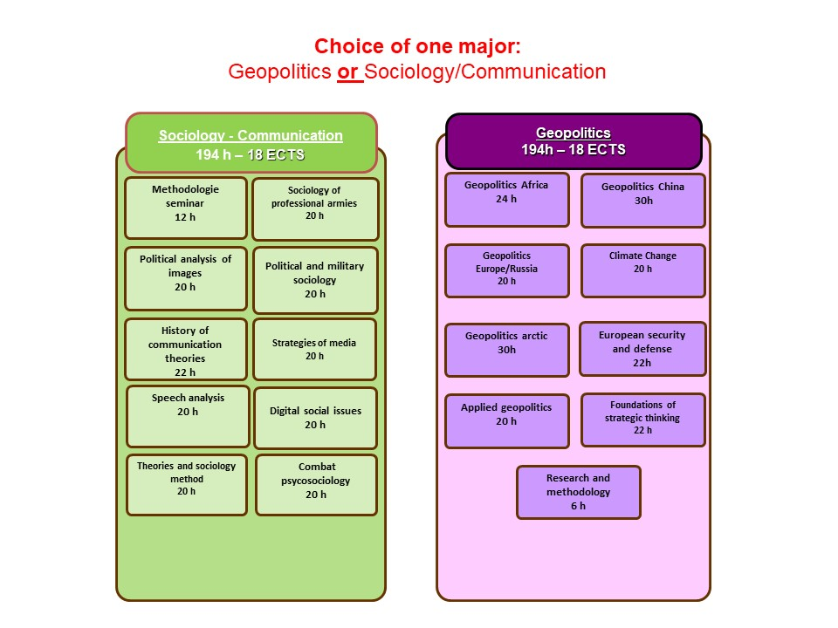

Courses Syllabus

COMMON CORE CURRICULUM

- PUBLIC AND MILITARY COMMAND AND DECISION MAKING
Cycle of 4 to 5 conferences given by Mr GHERARDI and senior state officials. The objective of these conferences is to open up students to the functioning of high authorities and decision-making mechanisms, including in the field of defense, at the interministerial level.

- GENERAL MILITARY TACTICS
- offensive maneuvers
- defensive maneuvers
- counter-rebellion operation
- Company level ROMULLUS exercise

- CASE STUDIES
During this course cadets will be dispatched in teams to work on a current operation of French forces, analyse the situation and present an operation briefing.
- FRENCH INSTITUTIONS
This course presents a dynamic approach to French political life and the institutions of the 5th Republic. Neither a constitutional law nor political science or history course in a strict sense, this course aims to present to international students, through a constitutional, political and historical detour, some realities and characteristics of French political life which will help them gain a transversal understanding of French issues.
- FRENCH DEFENCE POLICY
The course offers an overview of the French military. The various lectures focus on the current French Defense policy (including the most recent White Paper, and ongoing operations), the organization of the three services and their capabilities. A particular emphasis is laid on the Army (organization, recent engagements, equipment, Special Forces and the Foreign Legion).
- FRENCH MODERN LANGUAGE
This French language course is adapted according to the level of the student. Beginner courses, aim to familiarize with the basics of written and oral French language, through targeted and personalized exercises. Confirmed levels, enable students to strengthen their linguistic skills, through exercises and the study of authentic audio and written documents (films, programs, articles, books). For both levels, the aim of this course is to provide students with notions of civilization and contemporary French culture.
- FRENCH CIVILISATION
This course, delivered entirely in French is designed to provide foreign cadets with an understanding of French and French speaking culture, through geography, history, political institutions and cultural notions. Students will also be asked to work on a presentation in French on a topic of their choosing related to French culture or institutions.

MAJORS
OPTION 1: SOCIOLOGY AND COMMUNICATION

- Methodology seminar
This seminar aims first at training in research work: how to define a research subject and what are the differences with a report or a study? How to develop a problematic? How to use concepts to interpret an object? What are the research and survey methods (learning to put together an observation grid, an interview grid, etc.)? How to constitute a "corpus" of research? How to write, present a dissertation, use documents, etc.? Student monitoring also includes preparation for the thesis defense.

- Sociology of professional Army
Dealing with functional, structural and institutional issues as well as army-state and army-society relations within the framework of fully professionalized armies.
- Political analysis of images
The question of the image is a delicate one. In our information societies, it shapes representations and imaginations. The meaning and power of an image is thus an eminently political question. Beyond traditional media and the role of journalists, it will be a question of providing students with elements of reflection relating to sources of information and communication, old or more recent (internet, social networks, blogs, role and powers of cinema, documentary, photography, poster, etc.), producers of images and which constitute major issues in the representations of politics in general and the military in particular.

- Political and military sociology
The course is structured around the following questions: what is the political environment for military action? How does the "crisis situation" increase the political dimension of military action? What role do emotions play in armed violence? The aim of the course is to familiarize students with the socio-political environment in which military action is rooted.
- History of communication theories
The purpose of this course is to familiarize students who have chosen the information communication option with the sociology of media and communication. In this sense, it should be approached as an introduction to communication theories. Adopting, for reasons of intelligibility, a chronological approach, this module aims to bring out the contributions of the various currents, their possible articulations, their limits as well as the permanent ebb and flow of the issues raised.
- Media strategy
The aim of the course is to analyze the interactions of the media and public opinions, to discover the issue of media mechanisms in the world of global communication, to analyze the decoding grids of the communication cycle. The teaching to be delivered must achieve three objectives: 1. encourage future officers to reflect "political" on the special place of defense in the communication society; 2. provide the keys to the issue of communication for the armed forces, with its advantages and risks; 3. provide benchmarks on the support that communication can bring to military operations, particularly in the area of influence.
- Speech analysis
This module is designed as an initiation of students to discourse analysis. Each session is centered on the presentation of a fundamental notion of the discipline and that of research work illustrating the notions seen previously. The themes chosen relate to the coverage of conflicts or intervention by the French press, the discourse of the military institution and the communication of the military institution.
- Digital social issues
The purpose of this course is to take an interest in the social issues of digital technology. Beyond the debate between a simple change of scale or a real revolution, it will first be a question of taking stock of social science research on the subject, of seeing how sociology approaches this subject and how she is questioned by the latter. It will also be a question of examining certain dimensions: the uses, the actors and the social transformations that digital technology induces, starting from the postulate that technology is not neutral. The impact of digital transformations on defense and the military (strategic and political issues at the macro level, representations of the battlefield, digital warfare, cyber combatant status) will be the common thread of this teaching.
- Sociology theories and methods
To dispense the theories and fundamental knowledge (paradigms, authors, ...) of the sociological discipline with a view to conceptually arming the students.
- Combat psychology
Sociological and psychological approach to combat (effect of combat on identities, the question of fear, etc.)

OPTION 2: GEOPOLITICS

- Geopolitics Africa
The course will focus on the analysis of ongoing conflicts in the Sahelo-Saharan strip: origins of crises, social and societal factors, influence of Islamism, Serval and Barkhane operations. It will be based on a study of sources and documentation.
- Geopolitics China
This course aims to bring out China's strategies on a global scale.
- Geopolitics Relations between Europe and Russia
The purpose of this course is to highlight the strategies of Europe and Russia, major players in the region.
- Geopolitics Climate Change
Climate change has now grown from a scientific concern to one of the most pressing political issues of our time. Yet it continues to be often regarded as an environmental issue, which could be solved through technical measures and environmental policies. This course challenges this assumption and shows how climate change poses a significant challenge to international relations, as well as to the very concepts they rely on: territory, sovereignty, justice. As we are now entering the Anthropocene, the Age of Humans, what will international relations look like in a world transformed by climate change?
- Geopolitics Arctic
This course has the dual objective of clarifying the geopolitical transformations linked to climate change in the arctic zone and of showing the diversity of "artic worlds" by insisting on the issues linked to resources, transport, governance and management of the environment. A place will also be given to the multiple and sometimes contradictory representations of this part of the world.
- European Security and Defense
This course aims to analyze the political and institutional issues of the question of European security. The latter must be restored in the current complexity of the global geostrategic environment: in the era of globalization; distant threats can be as worrying as those close to them. Security and prosperity increasingly depend on an effective multilateral system.
- Applied Geopolitics
Geopolitics is a method of analysis that aims to study power rivalries over territories, and the populations who inhabit them. This course, in the form of tutorials, aims to allow students to acquire the methodologies of this discipline and apply them to concrete cases from the contemporary international situation. At the crossroads of geography, history, sociology and political science, geopolitics makes it possible to analyze conflict situations at different scales. It is an essential tool for learning to articulate the strategic, tactical and operational levels.
- Foundations of Strategic thinking
This seminar on the foundations of strategic thinking has two objectives. It reminds us of what strategy is as a scientific discipline. It will therefore be a question of trying to analyze the complex and interconnected aspects. On the other hand, recent wars and conflicts, in particular the wars in Iraq and / or the war of terrorism, call into question the very idea of the decisive battle and that of political victory. It will therefore be, from the study of these texts, to reflect on the modern implications of the classically stated strategic debate, to understand their concrete translations, and to identify what could be the contemporary additions to the foundations of the strategy.
- Research methology
This course aims to give students the bases necessary for writing a dissertation, orienting them on specific techniques for research in the field of international relations.

Application file documents:

- Application Form (p.9)

- Medical Certificate (p. 10)

- Reduced Medical Booklet (p. 11 – p.12)

Application Form

Military Academy of Saint-Cyr Coëtquidan
Please attach your head-and-shoulder photograph data.
Country of Origin:
Name of the Institute:

Course:
From:  (dd/mm/yy) |  | To:  (dd/mm/yy)

Male | Female | Rank | Surname | First name

Date of birth | Place of birth | Branch of Service | Major academic Field | Academic Year

Passport number | Phone number | e-mail address
ID number | Current address

Arrival at Rennes Airport (yes/no) | Arrival at Rennes rail station  (yes/no) | Arrival date (dd/mm/yy) | Time of arrival
Departure from Rennes Airport  (yes/no) | Departure from Rennes rail station  (yes/no) | Departure date (dd/mm/yy) | Time of departure

Special dietary or food requirements

Emergency contact/ Liaison staff:
Male | Female | Rank | Surname |  | First name
POC’s phone number |  |  |  | POC’s e-mail address

FRENCH MINISTRY OF DEFENSE

-------------------------
MILITARY HEALTH SERVICE

--------------------------
MEDICAL CERTIFICATE
(n°620-4/1)

SURNAME : FIRST NAME :

Birth date : Rank :

APTITUDES | Medical decision
General

Abroad & overseas

Paratrooper

Commando

Job’s restriction details
(if needed)

CONCLUSION: Date:
⁭ Aptitude without restrictions
⁭ Aptitude with restrictions Practitioner’s signature & stamp:
⁭ Inability

Reduced Medical Booklet

Surname: First Name:

Birth Date: Rank:

Medical Background
- Family :

- Medical :

- Surgical :

- Allergy :

Treatment :

Current Medical condition :

Job’s incapacity :

Height: Weight:

Blood Pressure: Pulse:

VACCINATION:

TYPE | Date of 1st injection | 2nd injection | 3rd injection
BCG
Diphtheria-Tetanus-Polio-Pertussis
Meningitis (A + C)
Hepatitis B
Measles-Mumps-Rubella
INFLUENZAE (H1N1 and seasonal)
Meningococcal Tetravalent (A + C + Y + W135
Typhoid
Hepatitis A
Yellow fever

Date : Practitioner’s stamp and signature :

